ROOTS OF RESILIENCE

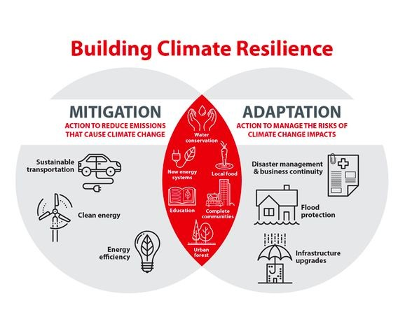

How Kenyan communities are innovating for a sustainable future

Version 2

Outline
- Introduction.
- The climate crisis is not just global,in Kenya, communities are living it and they are leading.
- Introduce the concept of community-led climate innovation: not top-down but bottom-up.
- Thesis: Kenya’s community-driven climate solutions in water, energy and land restoration offer hopeful, scalable pathways for other climate-vulnerable regions.
- Chapter 1: Water Security through Nature-Based Engineering
- The challenge: seasonal rivers, drought and water scarcity.
- Example: Sand dams in Makueni-how they are built, by whom and for what benefit.
- Impact: recharge of aquifers, reduced water loss, more reliable water year-round.
- Social dimension: community labor, local ownership, maintenance and resilience.
- Chapter 2: Greening the Land — Reforestation and Community Livelihoods.
- Harira Climate Resilience Initiative: planting native trees, restoring ecosystems and creating nurseries.
- Linking reforestation with income: fruit trees, beekeeping and nursery jobs.
- Co-benefits: biodiversity, watershed protection, local climate adaptation.
- Chapter 3: Youth, Women & Green Businesses.
- COLECA Project (Homa Bay): empowering youth and women to run green businesses in horticulture and tree nurseries.
- How training and capacity-building is paired with climate adaptation.
- The link between economic empowerment and climate resilience.

- Chapter 4: Circular Economy & Innovation.
- Eco-Loop Kenya: their work in waste management, recycling and circular economy.
- Plastic waste → low-cost building materials, bioenergy or other sustainable products.
- The role of local knowledge and innovation in transforming “waste” into opportunity.
- Chapter 5: Clean Energy for Communities.
- Solar mini-grids in rural Kenya: their social and economic impact.
- Discussion: how decentralized renewable energy improves livelihoods, safety (reduces kerosene use) and gender outcomes.
- Geothermal energy in Kenya: Kenya as a leader in geothermal, its climate and economic implications.
- Chapter 6: The Water-Energy-Food Nexus.
- Explanation of the “nexus” approach.
- SNV’s LISTEN project: integrating water management, agriculture and climate-smart irrigation.
- Why this matters: resilience in arid and semi-arid regions, food security and ecosystem restoration.
- Chapter 7: Young Innovators & Grants.
- KCDF’s Young Environmentalist Innovation Challenge: youth-led climate innovation in Kenya.
- Spotlight on some winning projects: bioethanol from waste, recycled plastic building materials, pollination services, etc.
- The multiplier effect: how grants are turning ideas into scalable, community-led climate solutions.
- Chapter 8: Technology, Data and Climate Resilience.
- The potential of AI and data in climate adaptation relevance in Kenya. (tie in with research on AI for climate resilience in Africa).
- Citizen science and community monitoring: while not always in Kenya, the model of community-led data collection (e.g., flood monitoring) shows potential.
- How localized weather data, early warning systems and community hubs strengthen resilience.
- Chapter 9: Challenges & Risks.
- Land rights, governance and carbon-credit tensions (displacement, community consent) — some communities in Kenya have pushed back.
- Funding sustainability: grants are great, but long-term models are needed.
- Maintaining community engagement, scaling without losing local ownership.
- Chapter 10: Scaling & Future Pathways.
- How these models can be replicated in other climate-vulnerable regions.
- Policy implications: working with county governments, integrating into national climate frameworks (Sustainable Solutions Kenya’s model).
- The role of young changemakers and climate hubs (e.g., Kenya Youth Climate Hub).
- Call to action: investment, partnerships and support for community-led climate innovation.
- Conclusion
- Restate: the power of community-led climate innovation in Kenya.
- Big picture: these are not just “local fixes”they are globally relevant models.
- A hopeful note: the future of climate solutions may very well be rooted in communities, not just policy or big tech.

Introduction
In the sun-scorched hills of southeastern Kenya, once-dry riverbeds are quietly transforming. Communities that used to walk miles to fetch water during drought are now gathering around sand dams, simple concrete structures that store water in sand. These dams don’t just quench thirst; they fuel hope. In several counties, grassroots efforts to restore rivers and landscapes are redefining what climate resilience means.
This story is not about catastrophe. It is about creativity, agency and the slow, steady work of building a sustainable future from the ground up. From youth-led green startups to communal reforestation projects, Kenyan communities are showing how local action can spark scalable climate solutions,why climate resilience must grow from those most affected by change.

Water security through nature-based engineering.

Sand dams as a lifeline
One of Kenya’s most powerful community-driven climate innovations is the sand dam. In arid and semi-arid regions, especially in counties like Makueni and Machakos, seasonal rivers flow only briefly each year. Historically, rainwater came and went too fast for locals to harness it, but sand dams are changing that.
These dams are built across seasonal riverbeds using reinforced concrete to hold back sand. As water runs during rainy seasons, coarse sand accumulates behind the dam, forming a reservoir. Over time, this sand reservoir holds water, which seeps into the ground and can be accessed through shallow wells.
What truly makes this a climate-resilient solution is ownership. Local community members provide labor and local materials, while partners like NGOs offer technical design and support. After construction, communities are responsible for maintenance, reinforcing long-term sustainability.

Impact on livelihoods
The impact of sand dams ripples through entire communities. In Makueni, for example, reports show that water access has drastically improved, reducing the time spent fetching water especially during dry seasons.
Because water is stored under sand (rather than in open reservoirs), evaporation is minimized. This subterranean storage improves water security for domestic use and small-scale farming.
With more reliable water, families are adapting their livelihoods: growing vegetables, maize, beans and fruit close to home.
Better water access also supports public health. Improved hygiene reduces disease risk, while rising groundwater helps restore vegetation and watersheds.

Scaling and sustainability
The Makueni County Sand Conservation & Utilization Authority reports active partnerships with the Africa Sand Dam Foundation and local communities, resulting in multiple dams across several wards.
According to the Authority, its initiatives over recent years have built new sand dams in rivers like Kaluku, Ngutwa and Ilengeni.
Still, challenges remain. Hydrologists emphasize that proper siting is critical without assessing factors like soil type, rock formations and rainfall, some dams may underperform or be non-functional.
Nevertheless, sand dams are widely recognized as a cost-effective, community-centered climate adaptation one that works with the landscape rather than against it.

Youth-led innovation: Empowering the next generation

KCDF’s Young Environmentalist Innovation Challenge (YEIC)
Kenya’s youth are not just waiting for climate solutions, they are building them. Through the Kenya Community Development Foundation (KCDF), the Young Environmentalist Innovation Challenge awarded KSh 53 million (~USD 350,000) to young innovators in 2025.
Over 400 applications were received and 12 winners (ages 15-35) were selected for projects that tackle clean energy, circular economy, climate-smart agriculture and conservation.
Some notable winners include:
- MOMA Renewable Energy (Kisii): Converts organic waste into bioethanol.
- M-Taka Waste Solutions (Kisumu): Recycles plastic waste into sustainable products.
- Eco Nasi (Machakos): Makes eco‐materials from pineapple pulp.
- Timao Group (Nairobi): Produces low-cost building materials from plastic waste.
- Megagas Alternative Energy (Nairobi): Converts plastic into clean cooking gas.
- CropScan Smart Farming (Nairobi): Uses AI + IoT for climate-resilient farming.
KCDF also launched the third edition of YEIC under the theme “Scaling Innovations for Environmental Impact”, targeting solutions ready to expand at scale.

Innovation hubs for youth
The Kenya Youth Climate Hub plays a pivotal role in supporting young climate innovators. Through mentorship, networking and access to resources, the Hub enables youth to design and implement scalable climate-tech solutions.
Their 2025 Youth Climate Innovation Challenge prioritized innovations for informal settlements, focusing on WASH (water, sanitation, hygiene), flood resilience and renewable energy.

Circular economy & waste innovation

Plastic to purpose
Plastic pollution is a major challenge in Kenyan cities, but for innovators like Timao Group and Megagas Alternative Energy, plastic is an opportunity:
- Timao transforms plastic waste into affordable construction materials.
- Megagas converts plastic into clean cooking gas, reducing indoor air pollution and reliance on more harmful fuels.

Community recycling and local impact
These circular economy ventures do not just reduce waste, they create local jobs, especially for youth and informal waste pickers. By turning discarded plastic into valuable products, the initiatives help build climate resilience and economic inclusion simultaneously.

Sustainable land restoration and reforestation

Trees as climate guardians
Reforestation in Kenya goes beyond carbon, it’s economic and social. Through grassroots efforts, youth and women-run tree nurseries are restoring degraded land with native species. These nurseries not only sequester carbon but also provide fruit, stabilize soil and sustain local economies.

Youth and climate advocacy
Young environmental leaders, including those connected with climate hubs, are mobilizing communities through education and action. Their work is building social capital and nurturing a generation that understands climate and sustainability as deeply interlinked.

Integrating water, energy & food: The Nexus Approach
Some of Kenya’s most resilient climate solutions arise when communities treat water, energy and food as interconnected.
- Water from sand dams supports small-scale irrigation.
- Waste-to-energy startups convert organic and plastic waste into energy.
- Climate-smart agriculture powered by AI helps farmers maximize yield with limited water.
This nexus-based thinking helps communities optimize resources, reduce risk and build systems that can adapt to climate shocks.

Challenges and Trade-offs
No solution is without trade-offs. Key challenges include:
- Site Risk: If sand dams are poorly placed (unfavorable geology or soil), they may not function as intended.
- Water Quality: Without proper design (e.g., safe wells), there may be risk of contamination.
- Funding Dependence: Many youth-led projects rely on grant funding; sustainable business models are needed.
- Governance & Equity: Ensuring youth or women-led initiatives truly have decision-making power is critical.
- Policy Support: Scaling requires integrating community-led solutions into county/national climate policy frameworks.

Scaling pathways & global lessons
Kenya’s grassroots climate work provides practical lessons for other climate-vulnerable regions:
- Sand Dams: Low-cost, community-led and replicable in other dry areas.
- Youth Innovation: Investing in young changemakers yields scalable, locally relevant climate solutions.
- Circular Economy: Transforming waste into value aligns sustainability with economic growth.
- Systems Thinking: Integrating water, energy and food builds stronger resilience.
- Partnerships Matter: Collaboration across community, government and funders is essential.

Conclusion
Kenya’s story of climate resilience is not just one of adaptation,it is one of agency and innovation. In the sand-dam-building communities, youth-led clean tech enterprises and reforestation cooperatives, we see resilience rooted in local wisdom, shared work and forward-thinking ambition.
These are not temporary fixes. They are scalable models. And they challenge a powerful narrative: that climate solutions must come from the outside. In Kenya, resilience is growing from within.
If supported, invested in and amplified, these community-led models could shape a global path forward showing that real climate change solutions begin where people live.

References notes
- KCDF grants and youth innovators — The Star. The Star+2The Star+2
- KCDF YEIC details and winners — Econews Kenya. Eco News
- KCDF third edition challenge info — FundsforNGOs. FundsforNGOs News
- Kenya Youth Climate Hub overview + challenge 2025. kenyayouthclimatehub.org+1
- Sand dam construction and community impact — VOA News. Voice of America
- Makueni County Sand Authority and partnership data. makuenisandauthority.go.ke
- Sand Authority role and environmental benefits — Makueni County Government. Government of Makueni County
- Technical data on rain-water harvesting & sand dams in Makueni. researchinventy.com

Captions images
A sand dam in Makueni County, Kenya, capturing water in seasonal riverbeds to recharge groundwater.
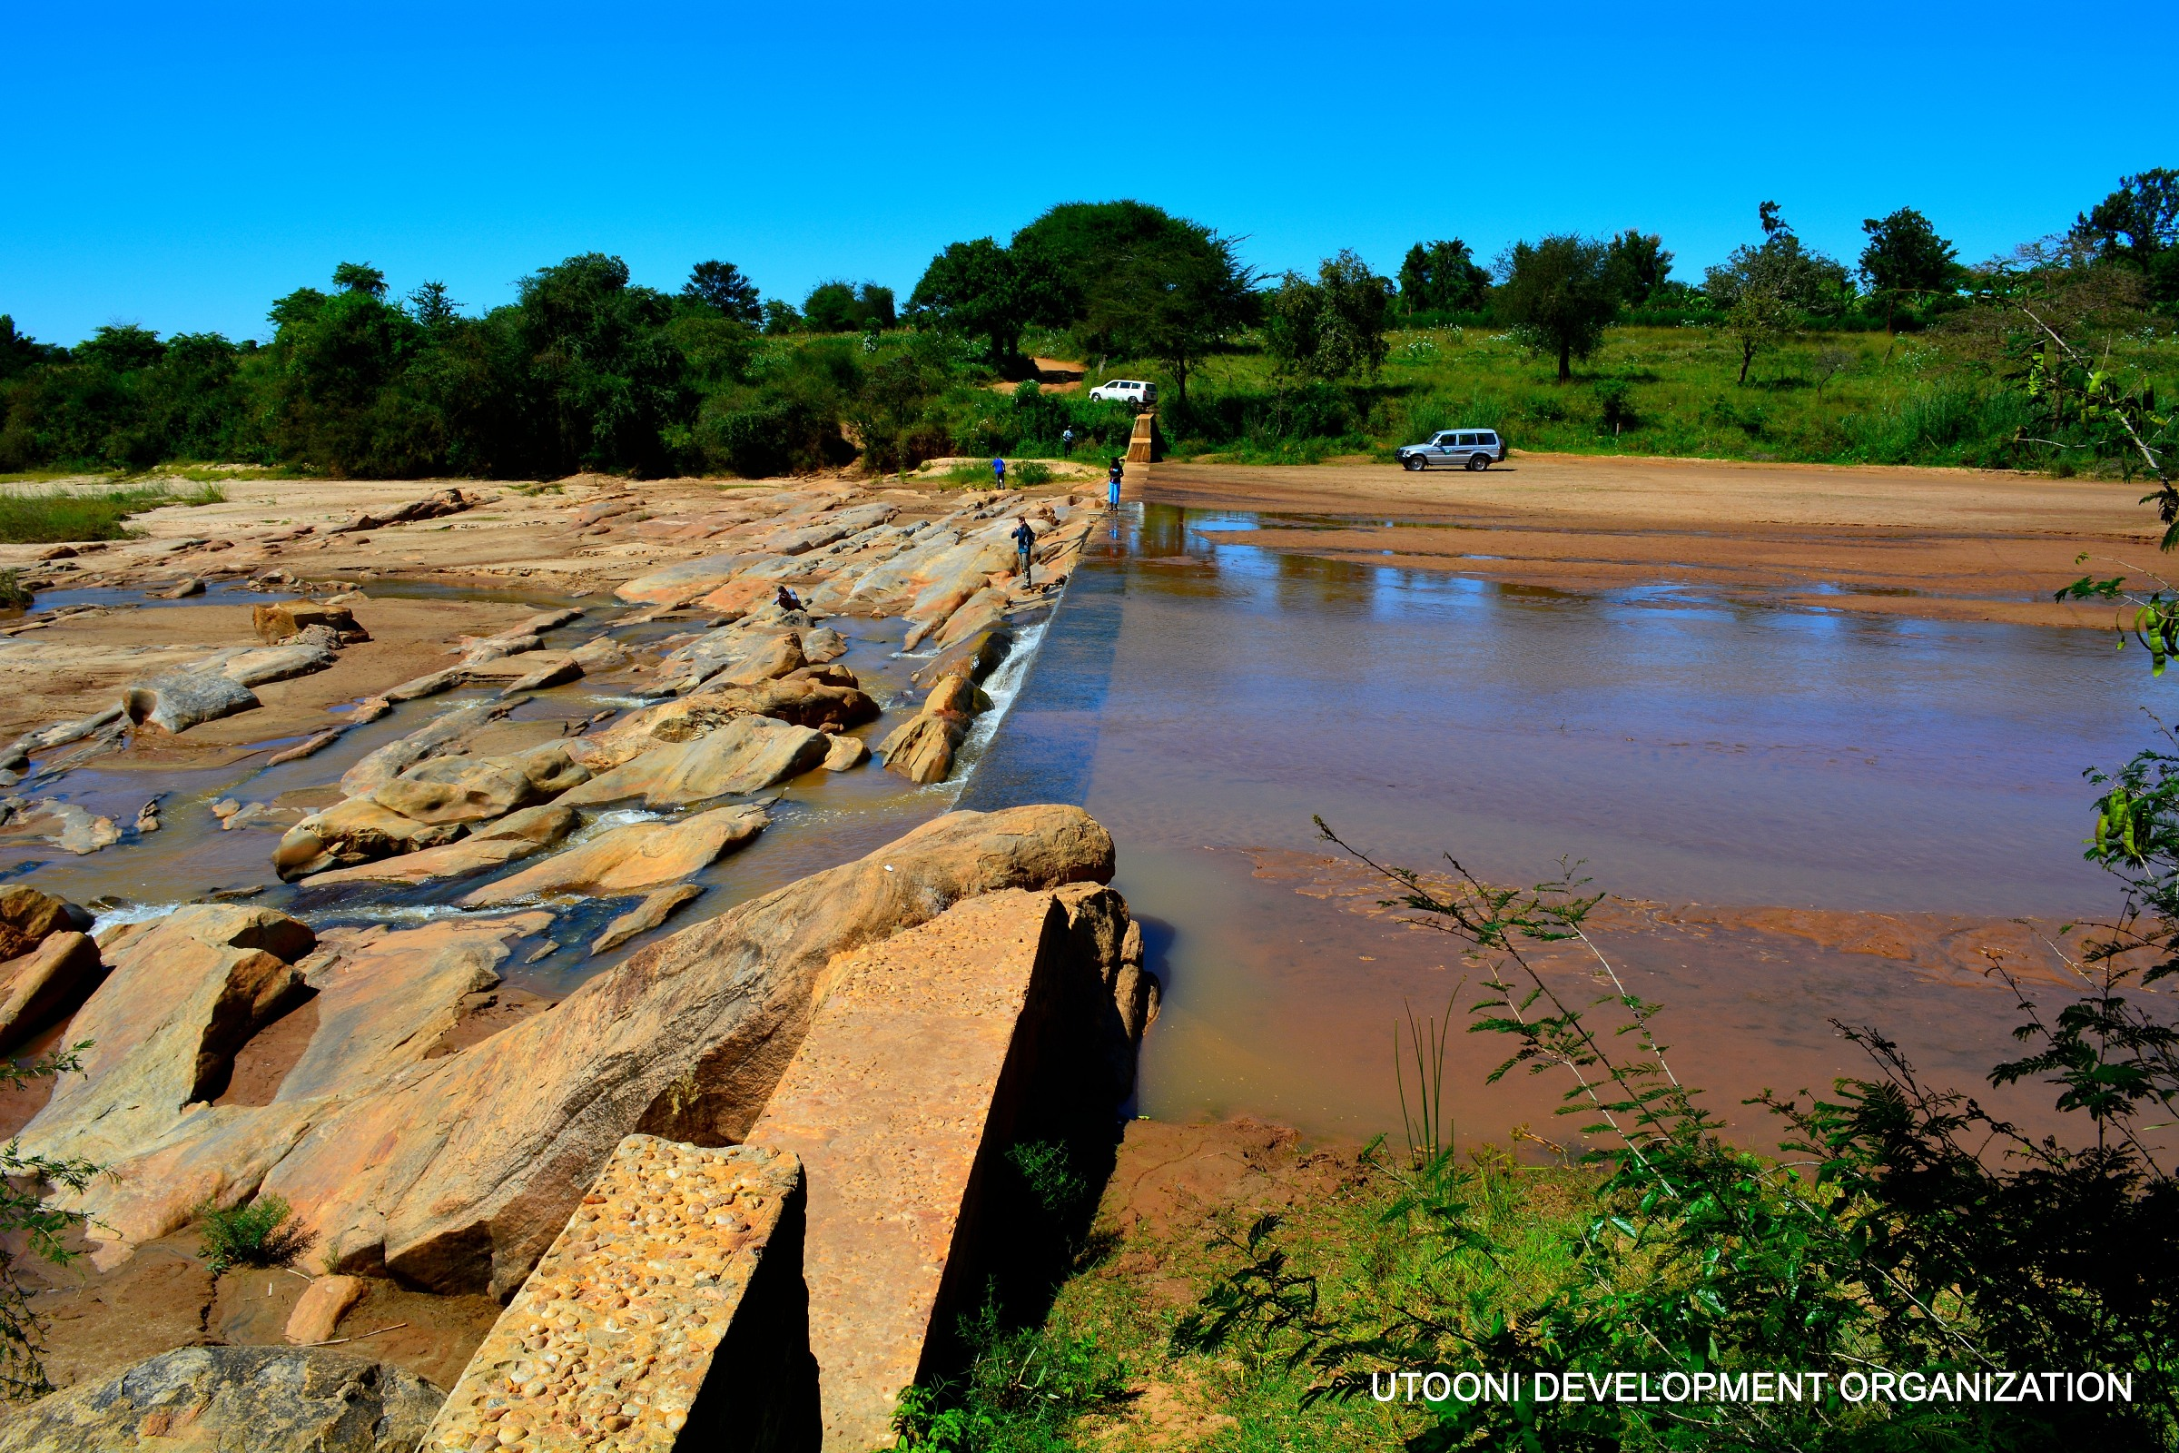
Community members in Machakos building a sand dam together, a collective effort for long-term water security.
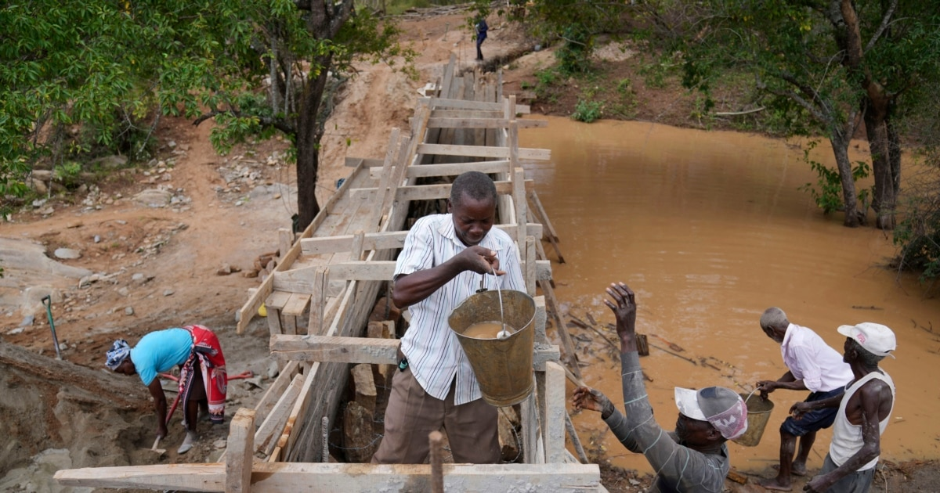

Young innovators at the Kenya Youth Climate Hub pitching ideas during a climate challenge event.

Restoration team working at a sand-dam site in Makueni, combining conservation and agriculture.
